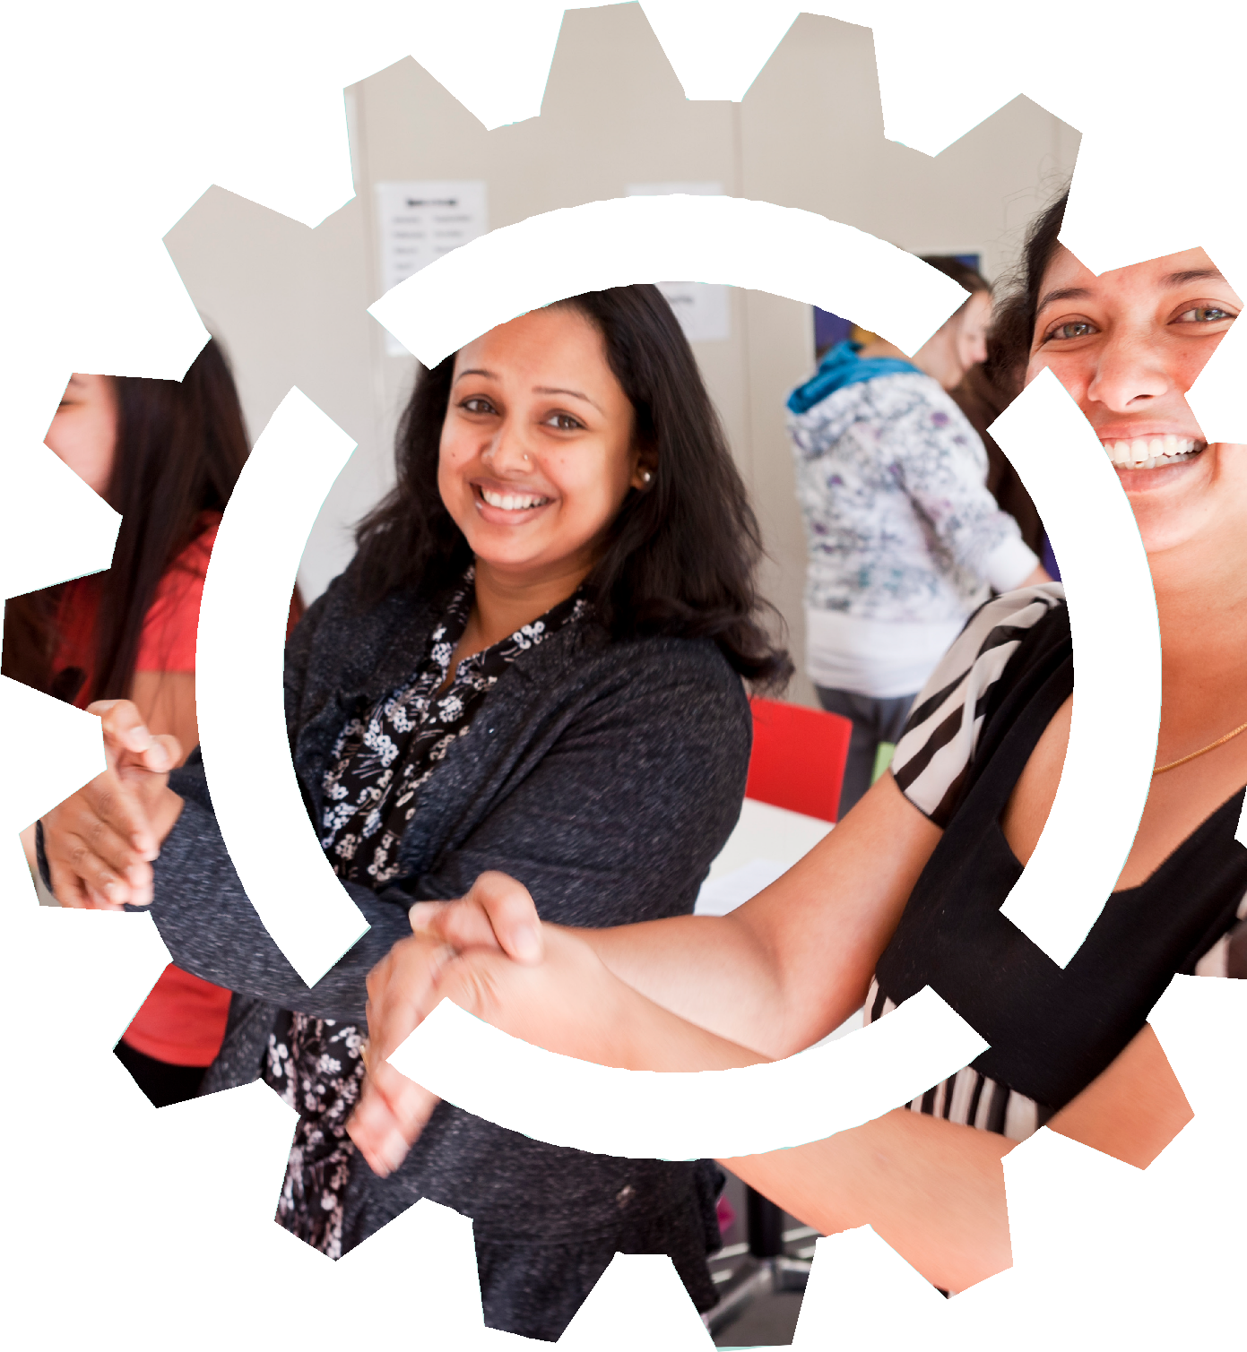
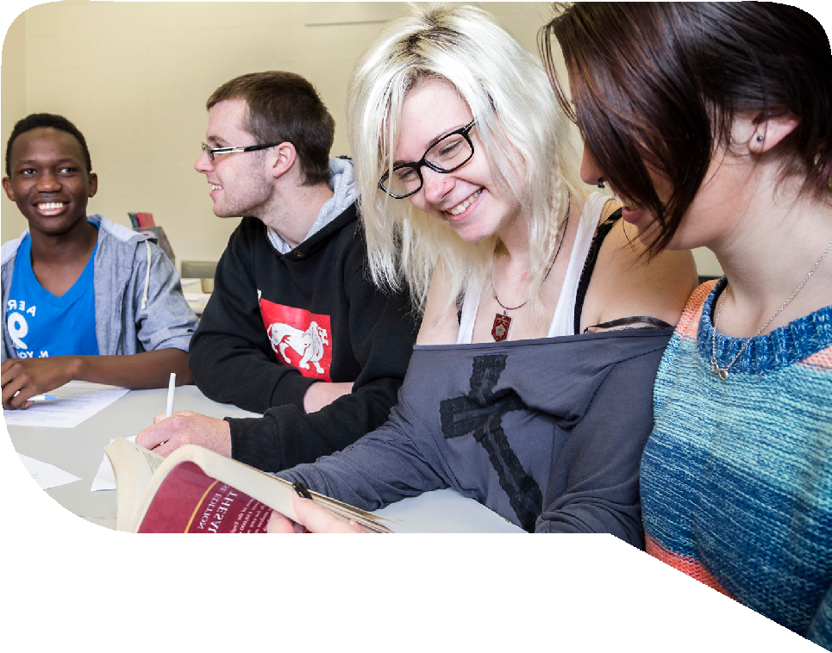
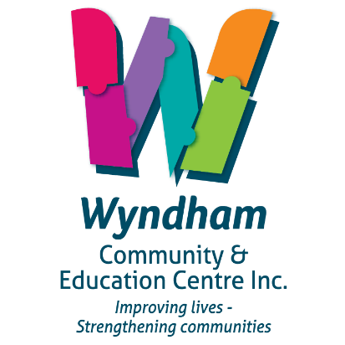

HEALTHY
LEARNING HEALTHY
LIVES

Over 100 free events across Wyndham for all ages and
interests including cooking, workshops and tours.
LOOK OUT FOR THE FESTIVAL PROGRAM IN AUGUST

proudly supported by

